AWS services and resources create
VPc
PS C:\WINDOWS\system32> Write-Output "Created public subnet: $subnetPubId in $az1"
Created public subnet: in a
PS C:\WINDOWS\system32>
PS C:\WINDOWS\system32> $REGION = "ap-south-1"
PS C:\WINDOWS\system32> $VPC_NAME = "demoB-vpc"
PS C:\WINDOWS\system32> $TAG_OWNER = "balakrishna.bodavula@einfochips.com"
PS C:\WINDOWS\system32> $PREFIX = "demoB"
PS C:\WINDOWS\system32> $pubSubnetCidr = "10.10.1.0/24"
PS C:\WINDOWS\system32>
PS C:\WINDOWS\system32> $az1 = "${REGION}a"
PS C:\WINDOWS\system32> Write-Output $vpcId
PS C:\WINDOWS\system32> $vpcJson = aws ec2 create-vpc --cidr-block 10.10.0.0/16 --region $REGION | ConvertFrom-Json
PS C:\WINDOWS\system32> $vpcId = $vpcJson.Vpc.VpcId
PS C:\WINDOWS\system32> Write-Output "VPC Created: $vpcId"
VPC Created: vpc-0f699b77feec7ba18

Subnet
PS C:\WINDOWS\system32> $subnetPubJson = aws ec2 create-subnet `
>> --vpc-id $vpcId `
>> --cidr-block $pubSubnetCidr `
>> --availability-zone $az1 `
>> --region $REGION | ConvertFrom-Json
PS C:\WINDOWS\system32> $subnetPubId = $subnetPubJson.Subnet.SubnetId
PS C:\WINDOWS\system32> Write-Output "Subnet Created: $subnetPubId"
Subnet Created: subnet-02828afabb222fc0b

Internet gateway

PS C:\WINDOWS\system32> aws configure set region ap-south-1
PS C:\WINDOWS\system32>
PS C:\WINDOWS\system32> aws configure list
NAME : VALUE : TYPE : LOCATION
profile : <not set> : None : None
access_key : ****************U2V5 : shared-credentials-file :
secret_key : ****************PHp/ : shared-credentials-file :
region : ap-south-1 : config-file : ~/.aws/config
PS C:\WINDOWS\system32>
PS C:\WINDOWS\system32> $igwJson = aws ec2 create-internet-gateway --region $REGION | ConvertFrom-Json
PS C:\WINDOWS\system32> $igwId = $igwJson.InternetGateway.InternetGatewayId
PS C:\WINDOWS\system32> aws ec2 attach-internet-gateway --internet-gateway-id $igwId --vpc-id $vpcId --region $REGION
PS C:\WINDOWS\system32> aws ec2 create-tags --resources $igwId --tags Key=Name,Value="$PREFIX-igw",Key=Owner,Value=$TAG_OWNER --region $REGION

Error parsing parameter '--tags': Second instance of key "Key" encountered for input:
Key=Name,Value=demoB-igw,Key=Owner,Value=balakrishna.bodavula@einfochips.com
^
This is often because there is a preceding "," instead of a space.
PS C:\WINDOWS\system32> Write-Output "IGW created: $igwId"
IGW created: igw-0e087cfb175bdafd5
S C:\WINDOWS\system32> aws ec2 describe-internet-gateways `
>> --internet-gateway-ids $igwId `
>> --region $REGION `
>> --query 'InternetGateways[].Tags'
[
[
{
"Key": "Name",
"Value": "demoB-igw"
},
{
"Key": "Owner",
"Value": "balakrishna.bodavula@einfochips.com"
}
]
]

EC2 rouetables
C:\WINDOWS\system32> $routeTableJson = aws ec2 create-route-table `
>> --vpc-id $vpcId `
>> --region $REGION | ConvertFrom-Json
PS C:\WINDOWS\system32>
PS C:\WINDOWS\system32> $routeTableId = $routeTableJson.RouteTable.RouteTableId
PS C:\WINDOWS\system32> Write-Output "Route Table Created: $routeTableId"
Route Table Created: rtb-05cf1d4d9d9bfdcaa
PS C:\WINDOWS\system32> aws ec2 create-tags `
>> --resources $routeTableId `
>> --tags "Key=Name,Value=$PREFIX-public-rt" "Key=Owner,Value=$TAG_OWNER" `
>> --region $REGION
PS C:\WINDOWS\system32> aws ec2 create-route `
>> --route-table-id $routeTableId `
>> --destination-cidr-block 0.0.0.0/0 `
>> --gateway-id $igwId `
>> --region $REGION
{
"Return": true
}

PS C:\WINDOWS\system32> aws ec2 associate-route-table `
>> --subnet-id $subnetPubId `
>> --route-table-id $routeTableId `
>> --region $REGION
{
"AssociationId": "rtbassoc-067ab623d2067e4d5",
"AssociationState": {
"State": "associated"
}
}

Security group
C:\WINDOWS\system32> $MY_CIDR = "39.5.249.208/32"
PS C:\WINDOWS\system32> $sgJson = aws ec2 create-security-group `
>> --group-name "$PREFIX-sg" `
>> --description "Allow SSH only from my IP" `
>> --vpc-id $vpcId `
>> --region $REGION | ConvertFrom-Json
PS C:\WINDOWS\system32>
PS C:\WINDOWS\system32> $sgId = $sgJson.GroupId
PS C:\WINDOWS\system32> Write-Output "Security Group Created: $sgId"
Security Group Created: sg-0458205893904ccc9
PS C:\WINDOWS\system32> aws ec2 authorize-security-group-ingress `
>> --group-id $sgId `
>> --protocol tcp `
>> --port 22 `
>> --cidr $MY_CIDR `
>> --region $REGION
{
"Return": true,
"SecurityGroupRules": [
{
"SecurityGroupRuleId": "sgr-08e90b690fafafba0",
"GroupId": "sg-0458205893904ccc9",
"GroupOwnerId": "843976228479",
"IsEgress": false,
"IpProtocol": "tcp",
"FromPort": 22,
"ToPort": 22,
"CidrIpv4": "39.5.249.208/32",
"SecurityGroupRuleArn": "arn:aws:ec2:ap-south-1:843976228479:security-group-rule/sgr-08e90b690fafafba0"
}
]
}

Keypar details-
C:\WINDOWS\system32> $keyName = "$PREFIX-key"
PS C:\WINDOWS\system32>
PS C:\WINDOWS\system32> aws ec2 create-key-pair `
>> --key-name $keyName `
>> --region $REGION `
>> --query "KeyMaterial" `
>> --output text > "$keyName.pem"
PS C:\WINDOWS\system32>
PS C:\WINDOWS\system32> Write-Output "Key Pair created: $keyName.pem"
Key Pair created: demoB-key.pem
PS C:\WINDOWS\system32> icacls "$keyName.pem" /inheritance:r
processed file: demoB-key.pem
Successfully processed 1 files; Failed processing 0 files
PS C:\WINDOWS\system32> icacls "$keyName.pem" /grant:r "$($env:USERNAME):(R)"
processed file: demoB-key.pem
Successfully processed 1 files; Failed processing 0 files
PS C:\WINDOWS\system32> $amiId = aws ssm get-parameters `
>> --names "/aws/service/ami-amazon-linux-latest/al2023-ami-kernel-default-x86_64" `
>> --region $REGION `
>> --query "Parameters[0].Value" `
>> --output text
PS C:\WINDOWS\system32>
PS C:\WINDOWS\system32> Write-Output "AMI ID: $amiId"
AMI ID: ami-0d176f79571d18a8f

With AMI Id –

Ec2 Instance created-

C:\WINDOWS\system32> $instanceJson = aws ec2 run-instances `
>> --image-id $amiId `
>> --count 1 `
>> --instance-type t2.micro `
>> --key-name $keyName `
>> --security-group-ids $sgId `
>> --subnet-id $subnetPubId `
>> --associate-public-ip-address `
>> --tag-specifications "ResourceType=instance,Tags=[{Key=Name,Value=$PREFIX-ec2},{Key=Owner,Value=$TAG_OWNER}]" `
>> --region $REGION | ConvertFrom-Json
PS C:\WINDOWS\system32>
PS C:\WINDOWS\system32> $instanceId = $instanceJson.Instances[0].InstanceId
PS C:\WINDOWS\system32> Write-Output "EC2 Instance Created: $instanceId"
EC2 Instance Created: i-08f4c7c814aeb699a

Allocate Elastic IP
PS C:\WINDOWS\system32> $eipJson = aws ec2 allocate-address --region $REGION | ConvertFrom-Json
PS C:\WINDOWS\system32> $eipAllocId = $eipJson.AllocationId
PS C:\WINDOWS\system32> $eipPublicIp = $eipJson.PublicIp
PS C:\WINDOWS\system32>
PS C:\WINDOWS\system32> Write-Output "Elastic IP Allocated: $eipPublicIp"
Elastic IP Allocated: 13.205.6.216

Associate EIP to EC2
PS C:\WINDOWS\system32> aws ec2 associate-address `
>> --instance-id $instanceId `
>> --allocation-id $eipAllocId `
>> --region $REGION
{
"AssociationId": "eipassoc-0aa81b8c76392e5d9"
}
Check Your Elastic IP Again
PS C:\WINDOWS\system32> aws ec2 describe-addresses --region $REGION --query "Addresses[].PublicIp" --output text
13.201.217.15 13.205.6.216

PS C:\Users\151243> aws ec2 describe-instances --instance-ids $instanceId --region ap-south-1 --query "Reservations[0].Instances[0].ImageId"
"ami-0d176f79571d18a8f"

PS C:\Users\151243> aws ec2 describe-images --image-ids ami-0d176f79571d18a8f --region ap-south-1
{
"Images": [
{
"PlatformDetails": "Linux/UNIX",
"UsageOperation": "RunInstances",
"BlockDeviceMappings": [
{
"Ebs": {
"DeleteOnTermination": true,
"Iops": 3000,
"SnapshotId": "snap-0a07784b87b951ac9",
"VolumeSize": 8,
"VolumeType": "gp3",
"Throughput": 125,
"Encrypted": false
},
"DeviceName": "/dev/xvda"
}
],
"Description": "Amazon Linux 2023 AMI 2023.9.20251117.1 x86_64 HVM kernel-6.1",
"EnaSupport": true,
"Hypervisor": "xen",
"ImageOwnerAlias": "amazon",
"Name": "al2023-ami-2023.9.20251117.1-kernel-6.1-x86_64",
"RootDeviceName": "/dev/xvda",
"RootDeviceType": "ebs",
"SriovNetSupport": "simple",
"VirtualizationType": "hvm",
"BootMode": "uefi-preferred",
"DeprecationTime": "2026-02-15T00:00:00.000Z",
"ImdsSupport": "v2.0",
"SourceImageId": "ami-02b297871a94f4b42",
"SourceImageRegion": "us-west-2",
"FreeTierEligible": true,
"ImageId": "ami-0d176f79571d18a8f",
"ImageLocation": "amazon/al2023-ami-2023.9.20251117.1-kernel-6.1-x86_64",
"State": "available",
"OwnerId": "137112412989",
"CreationDate": "2025-11-17T16:52:48.000Z",
"Public": true,
"Architecture": "x86_64",
"ImageType": "machine"
}
]
}

aws ssm describe-instance-information --region ap-south-1
{
"InstanceInformationList": [
{
"InstanceId": "i-02d895442cb54818e",
"PingStatus": "Online",
"LastPingDateTime": "2025-11-20T14:10:09.483000+05:30",
"AgentVersion": "3.3.3050.0",
"IsLatestVersion": false,
"PlatformType": "Linux",
"PlatformName": "Amazon Linux",
"PlatformVersion": "2023",
"ResourceType": "EC2Instance",
"IPAddress": "192.168.56.198",
"ComputerName": "ip-192-168-56-198.ap-south-1.compute.internal",
"SourceId": "i-02d895442cb54818e",
"SourceType": "AWS::EC2::Instance"
},
{
"InstanceId": "i-08b79c4a2f0defc9e",
"PingStatus": "Online",
"LastPingDateTime": "2025-11-20T14:10:10.748000+05:30",
"AgentVersion": "3.3.3050.0",
"IsLatestVersion": false,
"PlatformType": "Linux",
"PlatformName": "Amazon Linux",
"PlatformVersion": "2023",
"ResourceType": "EC2Instance",
"IPAddress": "192.168.29.221",
"ComputerName": "ip-192-168-29-221.ap-south-1.compute.internal",
"SourceId": "i-08b79c4a2f0defc9e",
"SourceType": "AWS::EC2::Instance"
}
]
}

Trage groupa details –
TargetGroups": [
{
"TargetGroupArn": "arn:aws:elasticloadbalancing:ap-south-1:843976228479:targetgroup/mytg/cf9065ca532d85b1",
"TargetGroupName": "mytg",
"Protocol": "HTTP",
"Port": 80,
"VpcId": "vpc-0f699b77feec7ba18",
"HealthCheckProtocol": "HTTP",
"HealthCheckPort": "traffic-port",
"HealthCheckEnabled": true,
"HealthCheckIntervalSeconds": 30,
"HealthCheckTimeoutSeconds": 5,
"HealthyThresholdCount": 5,
"UnhealthyThresholdCount": 2,
"HealthCheckPath": "/",
"Matcher": {
"HttpCode": "200"
},
"TargetType": "instance",
"ProtocolVersion": "HTTP1",
"IpAddressType": "ipv4"

Traget group-
C:\Users\151243> $tgJson = aws elbv2 create-target-group `
>> --name mytg `
>> --protocol HTTP `
>> --port 80 `
>> --vpc-id vpc-0f699b77feec7ba18 `
>> --target-type instance `
>> --region ap-south-1 | ConvertFrom-Json
PS C:\Users\151243>
PS C:\Users\151243> $tgArn = $tgJson.TargetGroups[0].TargetGroupArn
PS C:\Users\151243> Write-Output "Target Group ARN: $tgArn"
Target Group ARN: arn:aws:elasticloadbalancing:ap-south-1:843976228479:targetgroup/mytg/cf9065ca532d85b1

Describe commands and details-

PS C:\Users\151243> aws ec2 describe-route-tables --region ap-south-1
{
"RouteTables": [
{
"Associations": [
{
"Main": false,
"RouteTableAssociationId": "rtbassoc-03db62cf54a6601cc",
"RouteTableId": "rtb-0af4f6668d2959cde",
"SubnetId": "subnet-00c7f7ce579260f8c",
"AssociationState": {
"State": "associated"
}
}
],
"PropagatingVgws": [],
"RouteTableId": "rtb-0af4f6668d2959cde",
"Routes": [
{
"DestinationCidrBlock": "192.168.0.0/16",
"GatewayId": "local",
"Origin": "CreateRouteTable",
"State": "active"
},
{
"DestinationCidrBlock": "0.0.0.0/0",
"NatGatewayId": "nat-0f57940405bcbc9d2",
"Origin": "CreateRoute",
"State": "active"
}
],
"Tags": [
{
"Key": "Owner",
"Value": "balakrishna.bodavula@einfochips.com"
},
{
"Key": "aws:cloudformation:stack-name",
"Value": "eksctl-eks-demo-1-cluster"
},
{
"Key": "DM",
"Value": "Shahid Raza"
},
{
"Key": "Name",
"Value": "eksctl-eks-demo-1-cluster/PrivateRouteTableAPSOUTH1B"
},
{
"Key": "ENDDate",
"Value": "30-11-2025"
},
{
"Key": "aws:cloudformation:stack-id",
"Value": "arn:aws:cloudformation:ap-south-1:843976228479:stack/eksctl-eks-demo-1-cluster/76467510-c506-11f0-aa05-0abe050859eb"
},
{
"Key": "Environment",
"Value": "dev"
},
{
"Key": "alpha.eksctl.io/cluster-oidc-enabled",
"Value": "false"
},
{
"Key": "Department",
"Value": "PES-Digital"
},
{
"Key": "aws:cloudformation:logical-id",
"Value": "PrivateRouteTableAPSOUTH1B"
},
{
"Key": "alpha.eksctl.io/cluster-name",
"Value": "eks-demo-1"
},
{
"Key": "Project",
"Value": "Internal POC"
},
{
"Key": "alpha.eksctl.io/eksctl-version",
"Value": "0.217.0"
},
{
"Key": "eksctl.cluster.k8s.io/v1alpha1/cluster-name",
"Value": "eks-demo-1"
},
{
"Key": "ManagedBy",
"Value": "eksctl"
}
],
"VpcId": "vpc-097641f46ffed269f",
"OwnerId": "843976228479"
},
{
"Associations": [
{
"Main": true,
"RouteTableAssociationId": "rtbassoc-090b7851b63a97e2f",
"RouteTableId": "rtb-030492faa49f29421",
"AssociationState": {
"State": "associated"
}
}
],
"PropagatingVgws": [],
"RouteTableId": "rtb-030492faa49f29421",
"Routes": [
{
"DestinationCidrBlock": "10.10.0.0/16",
"GatewayId": "local",
"Origin": "CreateRouteTable",
"State": "active"
}
],
"Tags": [],
"VpcId": "vpc-09e96a86a13653bbd",
"OwnerId": "843976228479"
},
{
"Associations": [
{
"Main": false,
"RouteTableAssociationId": "rtbassoc-067ab623d2067e4d5",
"RouteTableId": "rtb-05cf1d4d9d9bfdcaa",
"SubnetId": "subnet-02828afabb222fc0b",
"AssociationState": {
"State": "associated"
}
}
],
"PropagatingVgws": [],
"RouteTableId": "rtb-05cf1d4d9d9bfdcaa",
"Routes": [
{
"DestinationCidrBlock": "10.10.0.0/16",
"GatewayId": "local",
"Origin": "CreateRouteTable",
"State": "active"
},
{
"DestinationCidrBlock": "0.0.0.0/0",
"GatewayId": "igw-0e087cfb175bdafd5",
"Origin": "CreateRoute",
"State": "active"
}
],
"Tags": [
{
"Key": "Owner",
"Value": "balakrishna.bodavula@einfochips.com"
},
{
"Key": "Name",
"Value": "demoB-public-rt"
}
],
"VpcId": "vpc-0f699b77feec7ba18",
"OwnerId": "843976228479"
},
{
"Associations": [
{
"Main": true,
"RouteTableAssociationId": "rtbassoc-03ad88371dc6c7b3a",
"RouteTableId": "rtb-0de84b07018ebf5ce",
"AssociationState": {
"State": "associated"
}
}
],
"PropagatingVgws": [],
"RouteTableId": "rtb-0de84b07018ebf5ce",
"Routes": [
{
"DestinationCidrBlock": "10.10.0.0/16",
"GatewayId": "local",
"Origin": "CreateRouteTable",
"State": "active"
}
],
"Tags": [],
"VpcId": "vpc-0f699b77feec7ba18",
"OwnerId": "843976228479"
},
{
"Associations": [
{
"Main": false,
"RouteTableAssociationId": "rtbassoc-00ab37cc79a234fcd",
"RouteTableId": "rtb-0629dc21d0e45e03b",
"SubnetId": "subnet-0a4ca94a922fae1cd",
"AssociationState": {
"State": "associated"
}
},
{
"Main": false,
"RouteTableAssociationId": "rtbassoc-030d4e0fc3f97e2f1",
"RouteTableId": "rtb-0629dc21d0e45e03b",
"SubnetId": "subnet-070c40d66571ae2f1",
"AssociationState": {
"State": "associated"
}
}
],
"PropagatingVgws": [],
"RouteTableId": "rtb-0629dc21d0e45e03b",
"Routes": [
{
"DestinationCidrBlock": "192.168.0.0/16",
"GatewayId": "local",
"Origin": "CreateRouteTable",
"State": "active"
},
{
"DestinationCidrBlock": "0.0.0.0/0",
"GatewayId": "igw-01fb127ca3fb9bca4",
"Origin": "CreateRoute",
"State": "active"
}
],
"Tags": [
{
"Key": "ENDDate",
"Value": "30-11-2025"
},
{
"Key": "alpha.eksctl.io/eksctl-version",
"Value": "0.217.0"
},
{
"Key": "aws:cloudformation:stack-id",
"Value": "arn:aws:cloudformation:ap-south-1:843976228479:stack/eksctl-eks-demo-1-cluster/76467510-c506-11f0-aa05-0abe050859eb"
},
{
"Key": "eksctl.cluster.k8s.io/v1alpha1/cluster-name",
"Value": "eks-demo-1"
},
{
"Key": "Name",
"Value": "eksctl-eks-demo-1-cluster/PublicRouteTable"
},
{
"Key": "alpha.eksctl.io/cluster-name",
"Value": "eks-demo-1"
},
{
"Key": "Department",
"Value": "PES-Digital"
},
{
"Key": "aws:cloudformation:stack-name",
"Value": "eksctl-eks-demo-1-cluster"
},
{
"Key": "alpha.eksctl.io/cluster-oidc-enabled",
"Value": "false"
},
{
"Key": "aws:cloudformation:logical-id",
"Value": "PublicRouteTable"
},
{
"Key": "Environment",
"Value": "dev"
},
{
"Key": "ManagedBy",
"Value": "eksctl"
},
{
"Key": "DM",
"Value": "Shahid Raza"
},
{
"Key": "Project",
"Value": "Internal POC"
},
{
"Key": "Owner",
"Value": "balakrishna.bodavula@einfochips.com"
}
],
"VpcId": "vpc-097641f46ffed269f",
"OwnerId": "843976228479"
},
{
"Associations": [
{
"Main": true,
"RouteTableAssociationId": "rtbassoc-0e4a21cd34cbb415d",
"RouteTableId": "rtb-0a12b38d0f8a264df",
"AssociationState": {
"State": "associated"
}
}
],
"PropagatingVgws": [],
"RouteTableId": "rtb-0a12b38d0f8a264df",
"Routes": [
{
"DestinationCidrBlock": "172.31.0.0/16",
"GatewayId": "local",
"Origin": "CreateRouteTable",
"State": "active"
},
{
"DestinationCidrBlock": "0.0.0.0/0",
"GatewayId": "igw-075da2b11b87ef5a1",
"Origin": "CreateRoute",
"State": "active"
}
],
"Tags": [],
"VpcId": "vpc-0a533cc1071005815",
"OwnerId": "843976228479"
},
{
"Associations": [
{
"Main": true,
"RouteTableAssociationId": "rtbassoc-0f781794c5108b23f",
"RouteTableId": "rtb-0d8ab0c07ad933527",
"AssociationState": {
"State": "associated"
}
}
],
"PropagatingVgws": [],
"RouteTableId": "rtb-0d8ab0c07ad933527",
"Routes": [
{
"DestinationCidrBlock": "192.168.0.0/16",
"GatewayId": "local",
"Origin": "CreateRouteTable",
"State": "active"
}
],
"Tags": [],
"VpcId": "vpc-097641f46ffed269f",
"OwnerId": "843976228479"
},
{
"Associations": [
{
"Main": false,
"RouteTableAssociationId": "rtbassoc-068c3aadb7547669d",
"RouteTableId": "rtb-080b31d628fb2fe1f",
"SubnetId": "subnet-09d248ac8eeb0a530",
"AssociationState": {
"State": "associated"
}
}
],
"PropagatingVgws": [],
"RouteTableId": "rtb-080b31d628fb2fe1f",
"Routes": [
{
"DestinationCidrBlock": "192.168.0.0/16",
"GatewayId": "local",
"Origin": "CreateRouteTable",
"State": "active"
},
{
"DestinationCidrBlock": "0.0.0.0/0",
"NatGatewayId": "nat-0f57940405bcbc9d2",
"Origin": "CreateRoute",
"State": "active"
}
],
"Tags": [
{
"Key": "ENDDate",
"Value": "30-11-2025"
},
{
"Key": "eksctl.cluster.k8s.io/v1alpha1/cluster-name",
"Value": "eks-demo-1"
},
{
"Key": "Department",
"Value": "PES-Digital"
},
{
"Key": "DM",
"Value": "Shahid Raza"
},
{
"Key": "Owner",
"Value": "balakrishna.bodavula@einfochips.com"
},
{
"Key": "ManagedBy",
"Value": "eksctl"
},
{
"Key": "Project",
"Value": "Internal POC"
},
{
"Key": "alpha.eksctl.io/eksctl-version",
"Value": "0.217.0"
},
{
"Key": "aws:cloudformation:logical-id",
"Value": "PrivateRouteTableAPSOUTH1A"
},
{
"Key": "Name",
"Value": "eksctl-eks-demo-1-cluster/PrivateRouteTableAPSOUTH1A"
},
{
"Key": "alpha.eksctl.io/cluster-name",
"Value": "eks-demo-1"
},
{
"Key": "Environment",
"Value": "dev"
},
{
"Key": "alpha.eksctl.io/cluster-oidc-enabled",
"Value": "false"
},
{
"Key": "aws:cloudformation:stack-name",
"Value": "eksctl-eks-demo-1-cluster"
},
{
"Key": "aws:cloudformation:stack-id",
"Value": "arn:aws:cloudformation:ap-south-1:843976228479:stack/eksctl-eks-demo-1-cluster/76467510-c506-11f0-aa05-0abe050859eb"
}
],
"VpcId": "vpc-097641f46ffed269f",
"OwnerId": "843976228479"

nodes

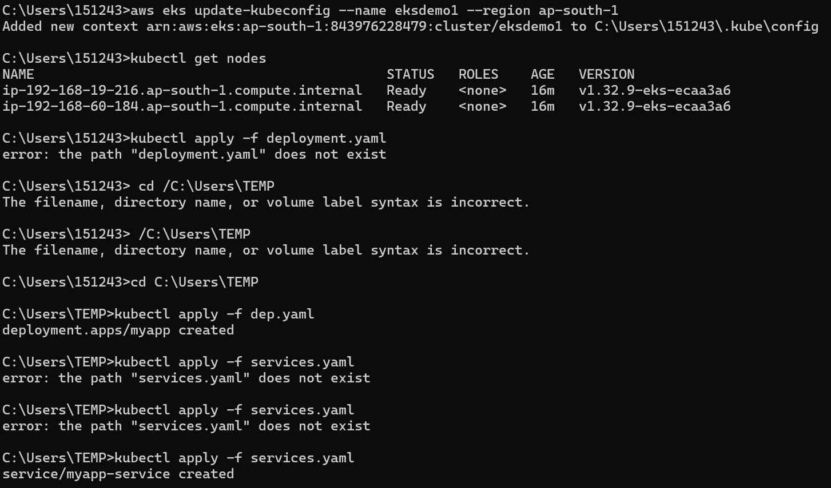

App services
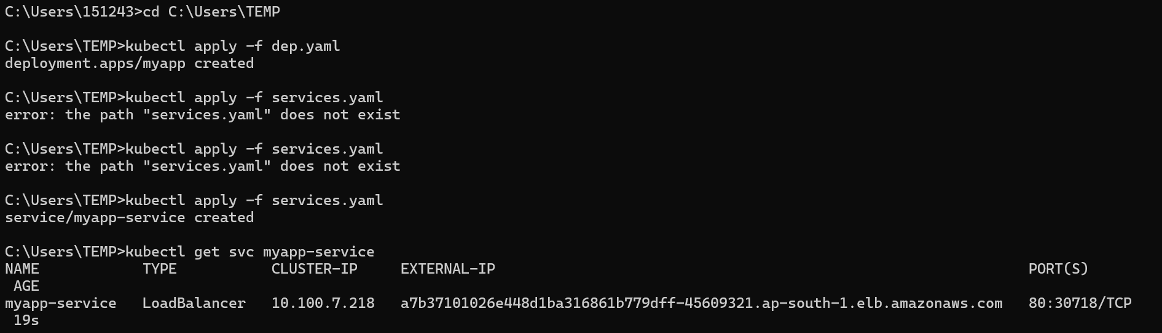

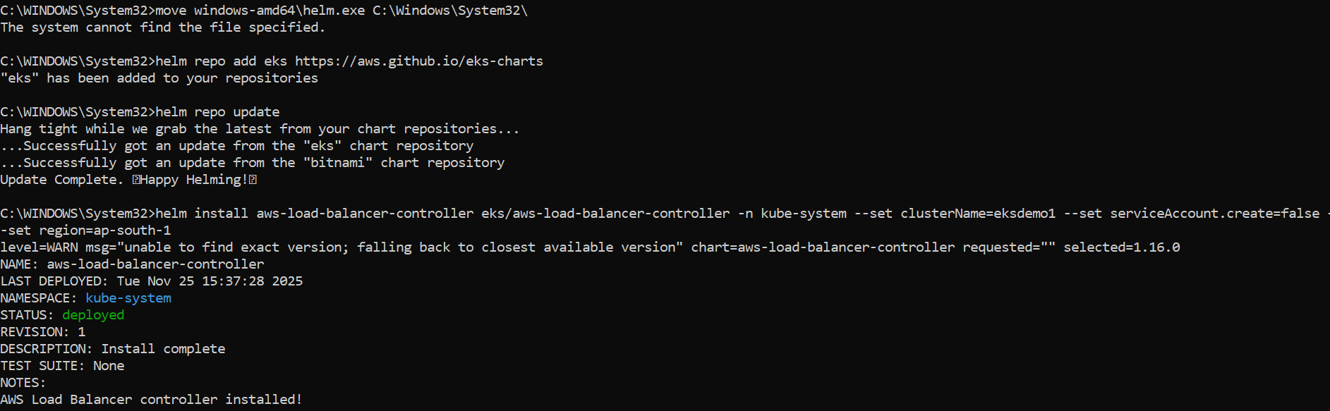

Load balancer- helm and node
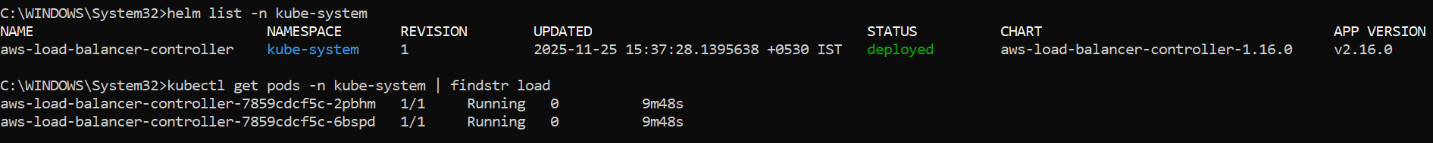

Auto scaling & node scaling
